Supplementary Material
Postural control learning dynamics in Parkinson’s disease: early improvement with plateau in stability, and continuous progression in flexibility and mobility
Zahra Rahmati, Saeed Behzadipour*, Alfred C. Schouten, Ghorban Taghizadeh, Keikhosrow Firoozbakhsh
* Correspondence: Corresponding Author: behzadipour@sharif.edu

- The pattern of improvements in K_{D} and K_{I}
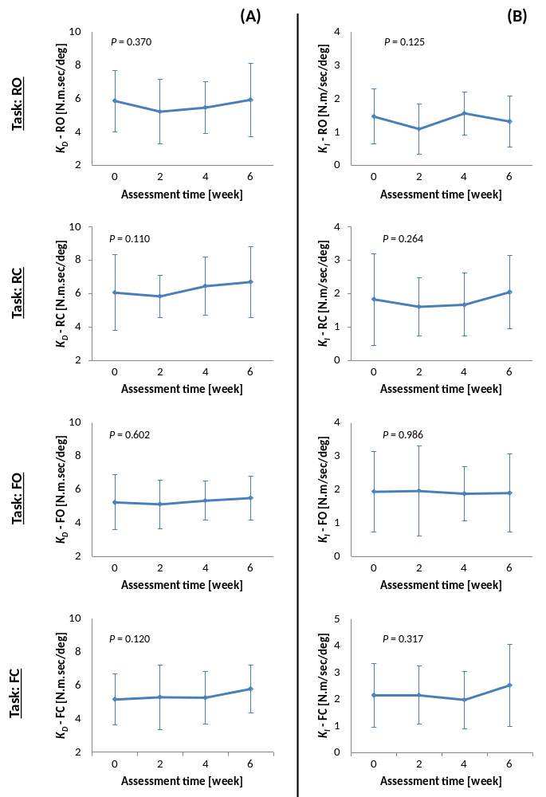
Figure S1 - The pattern of improvements for (A) K_{D} and (B) K_{I}, for patients with PD, at four time points (i.e. pre-, week 2, week 4, and post-training) during the balance-training program, and in all four tasks of stance on rigid surface (RO, RC), and stance on foam (FO, FC). All the changes were non-significant.

